**PRODUCT PAGE - HOLIDAY**

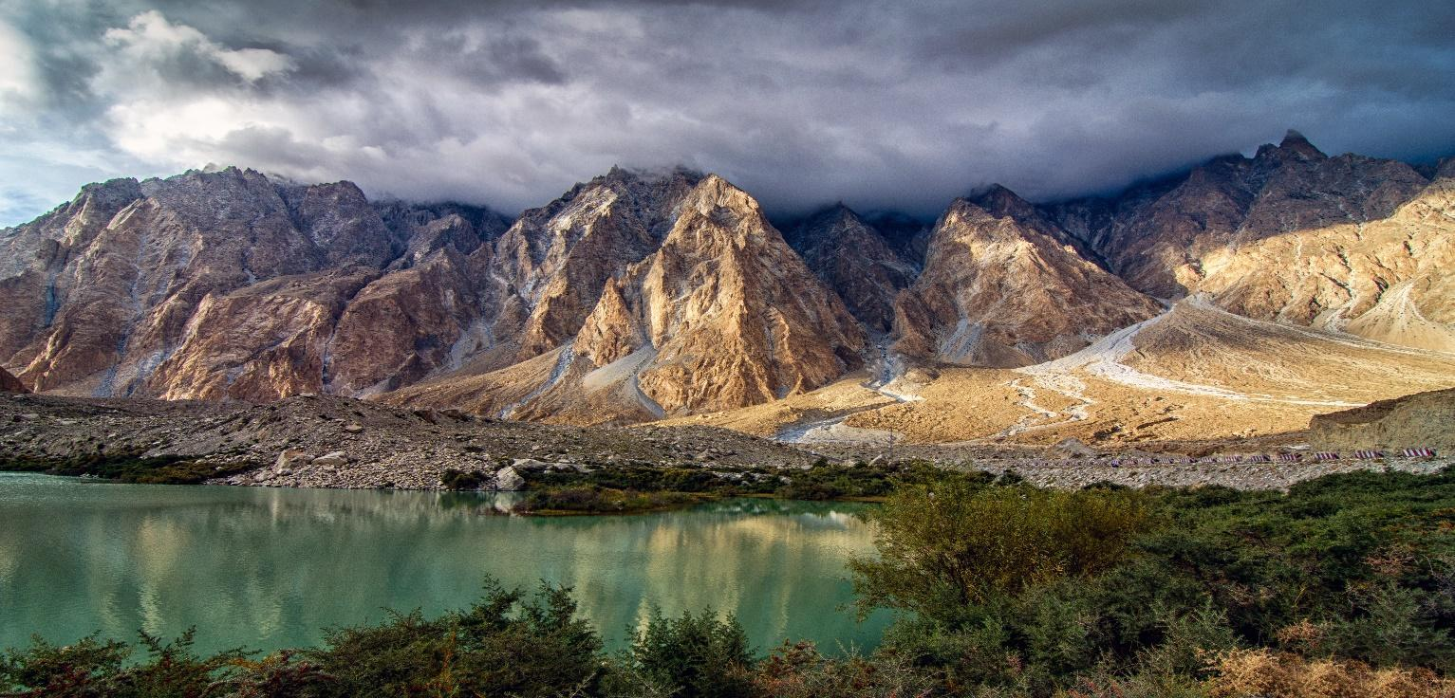

**The Ultimate Photography Heaven**

**Hunza & Nagar Valley**Traveling Dates: March → November

Product Code: PK23-04

**Duration:** 11 days

**Cost Per Person:** $2,900

**Style:** Nature, Culture, Heritage & Food

**Traveler’s Rating:** ★★★★

**Overview:**

Pakistan is a country full of diversity in every means whether you talk about landscape, food, culture or our traditions. Islamabad is the capital of Pakistan where our journey starts. Our Hunza landscape photography excursion will take you on a journey through some of the most stunning locations in the region. You will have the opportunity to capture breathtaking shots of the Hunza Valley, Passu Cones, and Attabad Lake, as well as explore traditional villages and cottage factories for carpets run by friendly women. You will also enjoy a village-to-village walk from Gulmit to Ghulkin, with beautiful scenery to capture along the way. The excursion will end with a detailed review session with your instructor, giving you the opportunity to receive valuable feedback on your work.

**Start:** Islamabad  
**Finish:** Islamabad  
**Provinces Covered:** Punjab & GB   
**Theme:** Holiday  
**Tour Type:** Luxury  
**Physical Rating: N/A**  
**Age Group:** 15+  
**Group Size:** 6+

**What you will experience:**

* Serenity of the capital of Pakistan (Islamabad)
* Dawn and dusks in Karakoram and Himalayas
* Heritage of Hunza
* Brightening moon at Karimabad and all the way to the vast fields of Punjab
* Serenity of Atabad and Borith Lake
* Culture of different provinces
* Some of the most delicious food country has to offer

**Is this trip right for you?**

Please note that a more conservative dress code applies for some of the sightseeing on the city tour. Entrance may be denied at some sights if this is not followed.

It is recommended that you wear warm clothes, long sleeves and long trousers/skirts/jeans.

The Jeep Safari on this itinerary involves off-road driving through rugged areas - which all adds to the excitement. However, because of the adventurous nature of the journey and the rough terrain covered, we do not recommend this activity to passengers if they have any pre-existing medical conditions, are over 70 or pregnant.

**Gallery:  
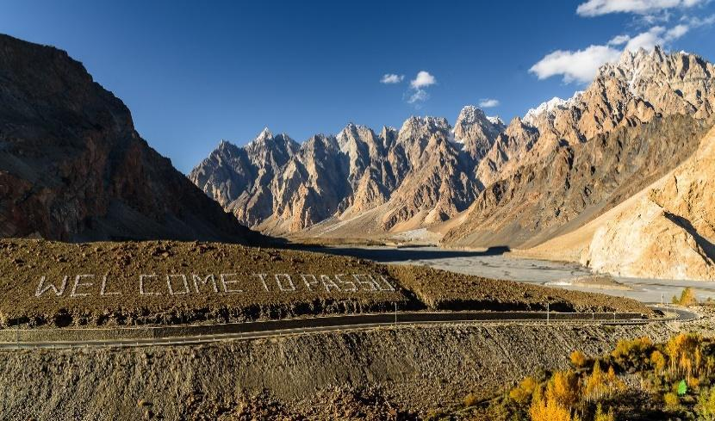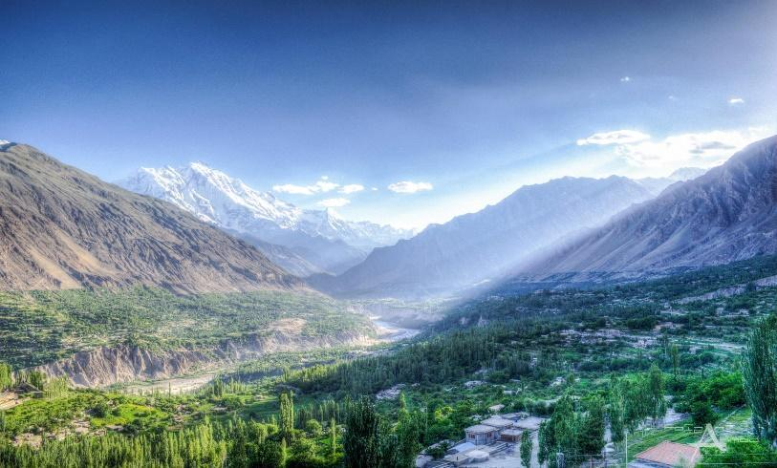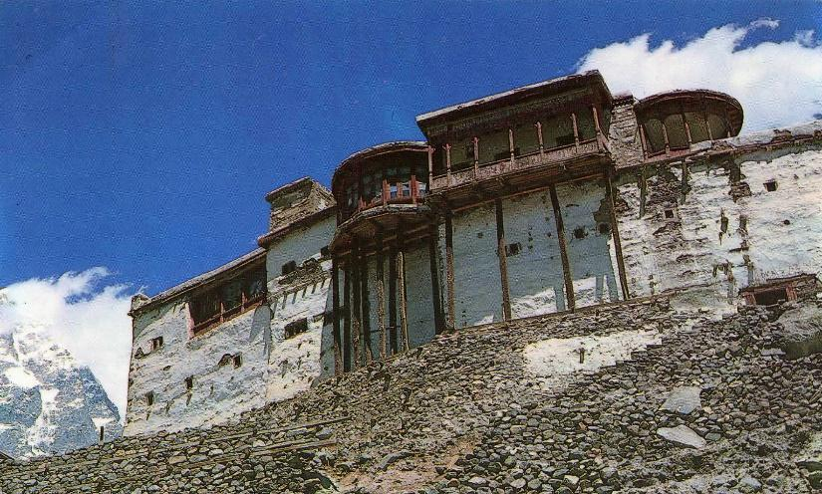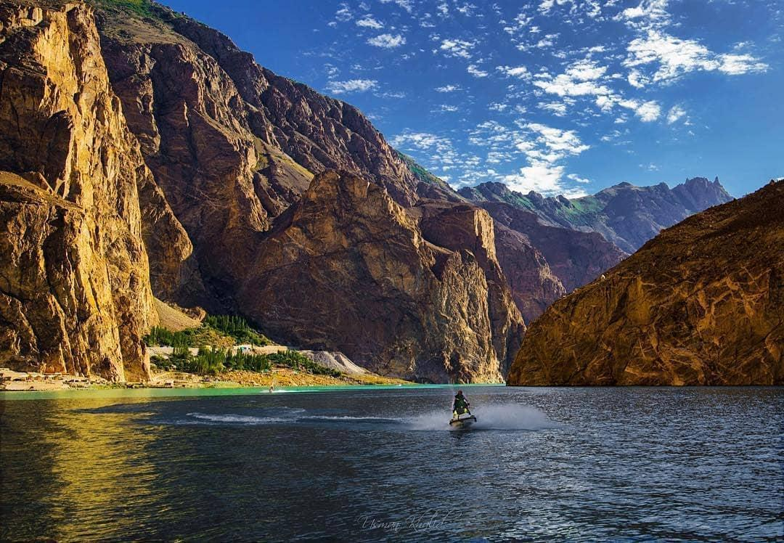**

**Itinerary:**

**Day 1: Arrival at Islamabad**KhushAmdeed, Welcome to Islamabad, Pakistan's capital. Our representative will meet you at the airport and transfer you to your hotel, just 20-25 minutes away. Spend the day exploring or shopping, then join us for an arrival dinner where you'll meet your Instructor and Guide at a handpicked restaurant. After a pleasant evening, rest at the hotel for the next day.  
**Accommodation:** Serena or Marriott Hotel   
**Activities:** Quick Tour Islamabad   
**Transport:** Grand Cabin  
**Meals:** Dinner

**Day 2: Gilgit & Minapin**  
Early morning, depart for Gilgit via a 45-minute flight from Islamabad. The breathtaking flight offers views of high-altitude peaks and mountain ranges. Upon arrival, transfer to the Rakaposhi viewpoint for an afternoon photoshoot, followed by lunch. Later, we'll visit Minapin before returning to Rakaposhi for a spectacular sunset photoshoot. Afterward, return to Minapin for dinner and a review session with the instructor. Rest up for the next day's adventures.  
**Accommodation:** PC Legacy or Roomy Yurts  
**Activities:** Safari flight, afternoon, sunset & blue light shoot at Rakaposhi.  
**Transport:** Grand Cabin  
**Meals:** 3 Meals

**Day 3: Rakaposhi**   
Enjoy an early morning sunrise shoot at Rakaposhi with various locations for capturing the majestic view. After breakfast, depart for Bikchum Ghutum, a 40-minute jeep ride from Minapin, to capture stunning views of Rakaposhi and Pisan glacier. Return to Minapin for rest before heading back to the Rakaposhi viewpoint for a sunset and blue light photoshoot. Dinner and review session with the instructor, followed by a night photography session at Rakaposhi. Return to the hotel for overnight stay.  
**Accommodation:** Pc Legacy or Roomy Yurts  
**Activities:** Sunrise at Rakaposhi, afternoon shoot at Bikchum Ghutum, sunset & blue light at Rakaposhi   
**Transport:** Jeeps & Grand Cabin  
**Meals:** 3 Meals

**Day 4: Duiker Point / Eagles Nest**After a stunning sunrise shot at Rakaposhi from a different angle, we will have breakfast. Then we will embark on an excursion to Duiker/Eagles nest and transfer back to the hotel for some rest. In the afternoon, we will have a photoshoot at Eagles nest, which provides a panoramic view of Hunza and Nagar surrounded by 7000+m peaks. Lunch will be served leisurely at Duiker. We will cover sunset and blue light photography from Duiker/Eagles nest, followed by dinner and our daily review and brainstorming sessions. Overnight stay  
**Accommodation**: Hard Rock resort  
**Activities:** Sunrise from Rehman Abad, afternoon, sunset and blue light shoot at Eagles Nest.  
**Transport:** Grand Cabin  
**Meals:** 3 Meals

**Day 5: Duiker and Nagar Valley**After a stunning sunrise shot at Duiker with views of 5 different 7000+m peaks, breakfast will be served. Rest for a while before departing for an afternoon shoot at Hopper valley in Nagar valley, a 1.5-hour drive from Karimabad. Photoshoot at hopper glacier and snow-covered peaks followed by lunch. Return to Eagles Nest for sunset and blue light photoshoot. Dinner and review session will be held followed by a bonfire and traditional musical night. A night shoot from the duiker point will be instructed by the tutor, with the option for time-lapse. Overnight stay.  
**Accommodation**: Hard Rock resort or Eagles Nest  
**Activities:** Sunrise at Duiker point, afternoon session at Hopper, sunset, blue light and night shoot at Duiker/Eagles Nest  
**Transport:** Grand Cabin  
**Meals:** 3 Meals

**Day 6: Baltit and Altit Fort**  
We will start the day with a heritage walk from Karimabad bazaar to Baltit Fort, where we will learn about Hunza Valley's history, culture, and traditions. After the tour, we will walk back to Karimabad bazaar for an excursion to Altit Fort, followed by a stop at Khabasi Café, an all-female-operated cafe. Later, we will take an evening walk in Altit Royal Gardens and return to Karimabad bazaar for some free shopping time. Dinner will be served at the hotel with traditional dance and music  
**Accommodation:** Offto.pk  
**Activities:** Karimabad heritage walk, Baltit and Altit fort tour, Altit royal gardens, khabasi Café and traditional music and dances.  
**Transport:** Mostly walking and Grand Cabin  
**Meals:** 3 Meals

**Day 7: Upper Hunza**Early breakfast, depart to Passu Cathedral from Atabad lake. Check in at the resort. Afternoon photoshoot at Atabad lake, followed by a visit to Borith lake for a photoshoot of Ultar and Shispar Peak. Return for sunset and blue light photography at Passu cones, Passu peak and glacier. Dinner and review session with the instructor. Bonfire and traditional music by the lake. Overnight stay with the option for night photography at Atabad lake.  
**Accommodation**: Luxus Atabad Resort or Horizon Resort  
**Activities:** Sunset at Duiker, afternoon shoot at Atabad Lake & sunset at Passu Cones  
**Transport:** Jeeps & Grand Cabin  
**Meals:** 3 Meals

**Day 8: Passu Cathedral & Khunjerab pass**We will head out for a sunrise shoot from zero point to capture the stunning Passu cones and Passu glacier. After the shoot, we will return to the resort for breakfast and rest for a while. We will then embark on an excursion to Khunjerab Pass, the highest point of our journey, where we can capture breathtaking views of the high pastures and peaks from 5000m. On the way back, we will make a stop at Hussaini bridge to photograph the Passu Cones and Hussaini bridge during the afternoon shoot. Later, we will visit the Glacier Breeze Cafe for lunch and tea, followed by evening shots of the Passu cones from there. After returning to the resort and freshening up, dinner will be served with a review session with the instructor. Night shoots will be held, and we will spend the night at the resort.  
**Accommodation**: Luxus Atabad or Famree  
**Activities:** Sunrise at Passu, afternoon shoot at Passu & Hussaini Bridge, sunset and night shoot at Passu cones.  
**Transport:** Grand Cabin   
**Meals:** 3 Meals

**Day 9: Upper Hunza to Gilgit**We'll start the day with a sunrise shoot at Passu cones from Passu Village and Hussainabad before breakfast. After breakfast, we'll visit Gulmit village to explore the village life and Cottage factories for Carpets run by friendly women, an initiative taken by AKSDP for women empowerment in the region. We'll take a village to village walk from Gulmit to Ghulkin, capturing beautiful scenery along the way. We'll return to Atabad and depart for Gilgit, which is a 2.5-hour drive from Atabad. Upon arrival, we'll transfer to the hotel and hold a detailed review session with the instructor. Dinner will be served, followed by an overnight stay.  
**Accommodation**: Gilgit Serena   
**Activities:** Sunrise at Passu Cones and Village walk  
**Transport:** Grand Cabin  
**Meals:** 3 Meals

**Day 10: Islamabad and Monal**After breakfast, transfer to the airport and fly to Islamabad with stunning views of the Himalayas and Karakoram range. Check-in at the hotel and embark on a short city tour of Islamabad, including the Pakistan Monument and Faisal Masjid for afternoon photography. Then, visit Monal Margalla hills for panoramic sunset photography of Islamabad and Rawalpindi. Enjoy dinner at Monal restaurant before returning to the hotel for overnight stay.  
**Accommodation**: Marriott Hotel  
**Activities:** Flight safari, Islamabad city tour, Lok Virsa Museum and Monal.  
**Transport:** Flight & Grand Cabin  
**Meals:** 3 Meals

**Day 11: Day of Departure**Breakfast will be served at the hotel. visit Saidpur Village and Lunch at a handpicked restaurant by our team. shopping time at Centaurus mall and later transfer to the Airport with lots of memories to cherish forever.

**Accommodation**: None  
**Activities:** Departure to your country   
**Transport:** Flight  
**Meals:** Breakfast & Lunch

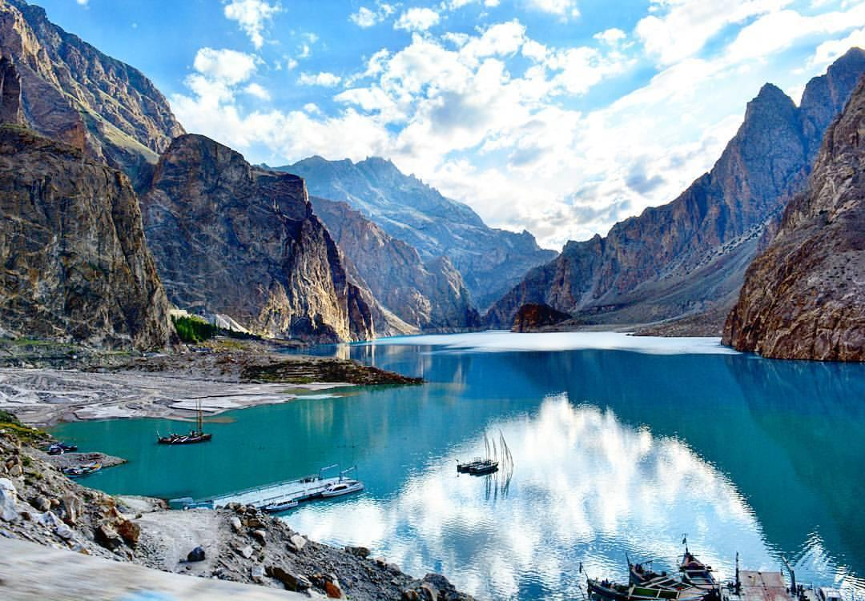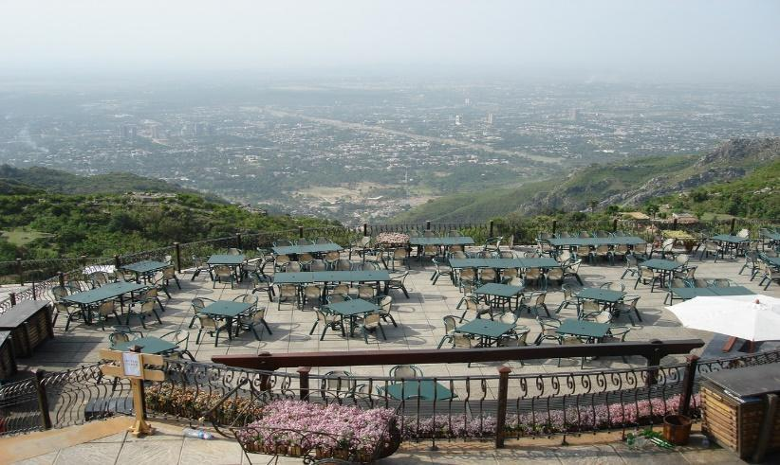

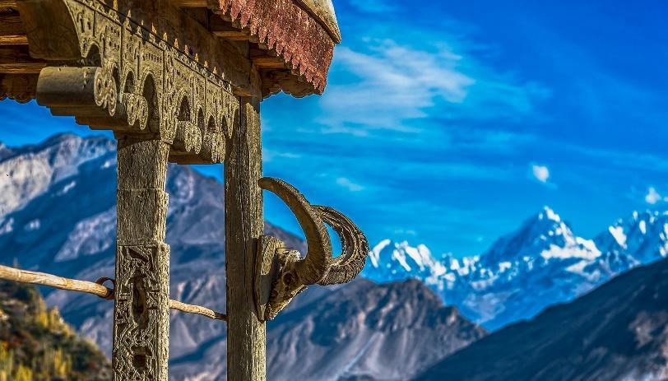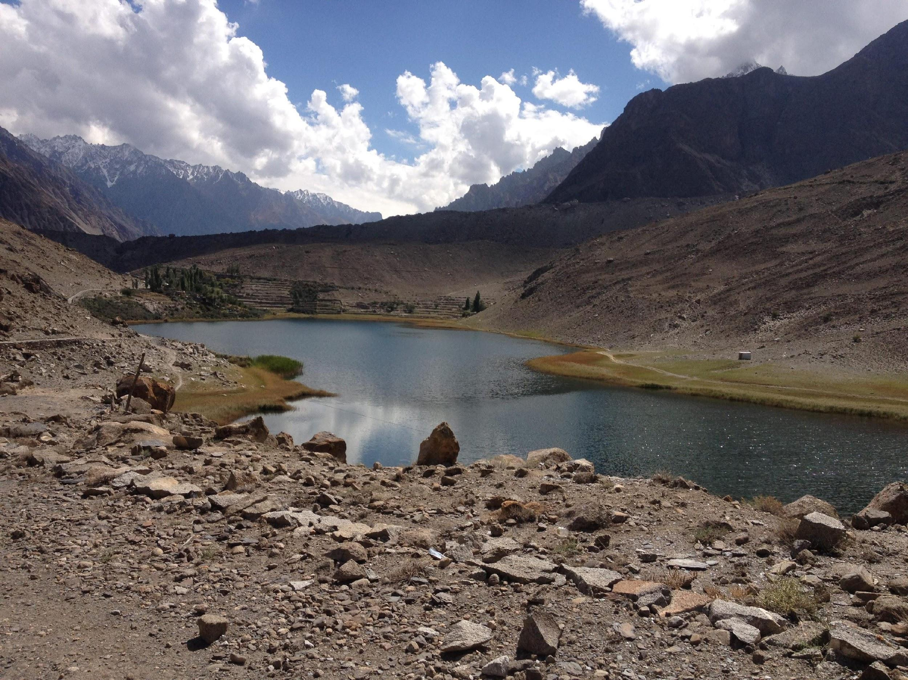

**Inclusions:**

| **Services** | **Deluxe Package** | **Premium Package** |
| --- | --- | --- |
| Transportation | Toyota Coaster & Jeeps | Toyota Coaster & Jeeps |
| Return Flight ISB→ GLT | Yes | Yes |
| Meals | 3 Meals/Daily | 3 meals/Daily |
| 2 Nights Islamabad | Ramada or Best western | Marriott Hotel |
| 2 Nights Minapin | Roomy Yurts | PC Legacy |
| 3 Nights Central Hunza | Eagles Nest | Hard Rock Resort |
| 2 Nights Upper Hunza | Famree Resort | Luxus Atabad Resort |
| 1 Night Gilgit | The Mandarin inn | Gilgit Serena |
| Souvenirs | Yes | Yes |
| Arrival & Farewell Dinner | Yes | Yes |
| 1 Local cuisine lunch in Heritage House | Yes | Yes |
| Traditional Musical Night with BBQ Dinner | Yes | Yes |
| English Speaking Guide | Yes | Yes |
| Driver, Guide, Toll, Parking Expense | Yes | Yes |
| Entry to all forts, Museum & Boating or any other activity | Yes | Yes |

**INCLUDED ACTIVITIES:**

* Day Tour Islamabad
* Sunset at Monal
* Saidpur Village
* Sunset and sunrise at Passu Cones
* Sunset and sunrise at Rakaposhi
* Sunset and sunrise at Duiker Point
* Afternoon shoot at hopper
* Afternoon shoot at Atabad Lake
* Afternoon shoot at Hussaini bridge & Passu
* Karimabad tour
* Passu glacier
* Afternoon shoot at Bikchum Ghutum

**Essential Trip Info:**  
Warm Clothes will be required in the northern region of Pakistan, rest the weather will be moderate.

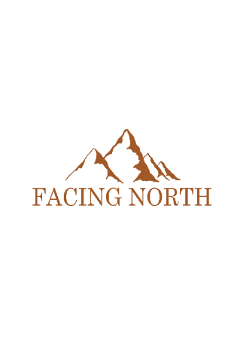

Hussain Mustansir (Founder, CEO)

+923367772152, +923115596785

Email: [facingnorthpk@gmail.com](mailto:facingnorthpk@gmail.com), [hussainmustansir@outook.com](mailto:hussainmustansir@outook.com)

Head Office

Plot #9, floor 3, midway commercial area,

Bahria Town phase 7, Islamabad, Pakistan.